2.1.1. Roots of a Quadratic Equation
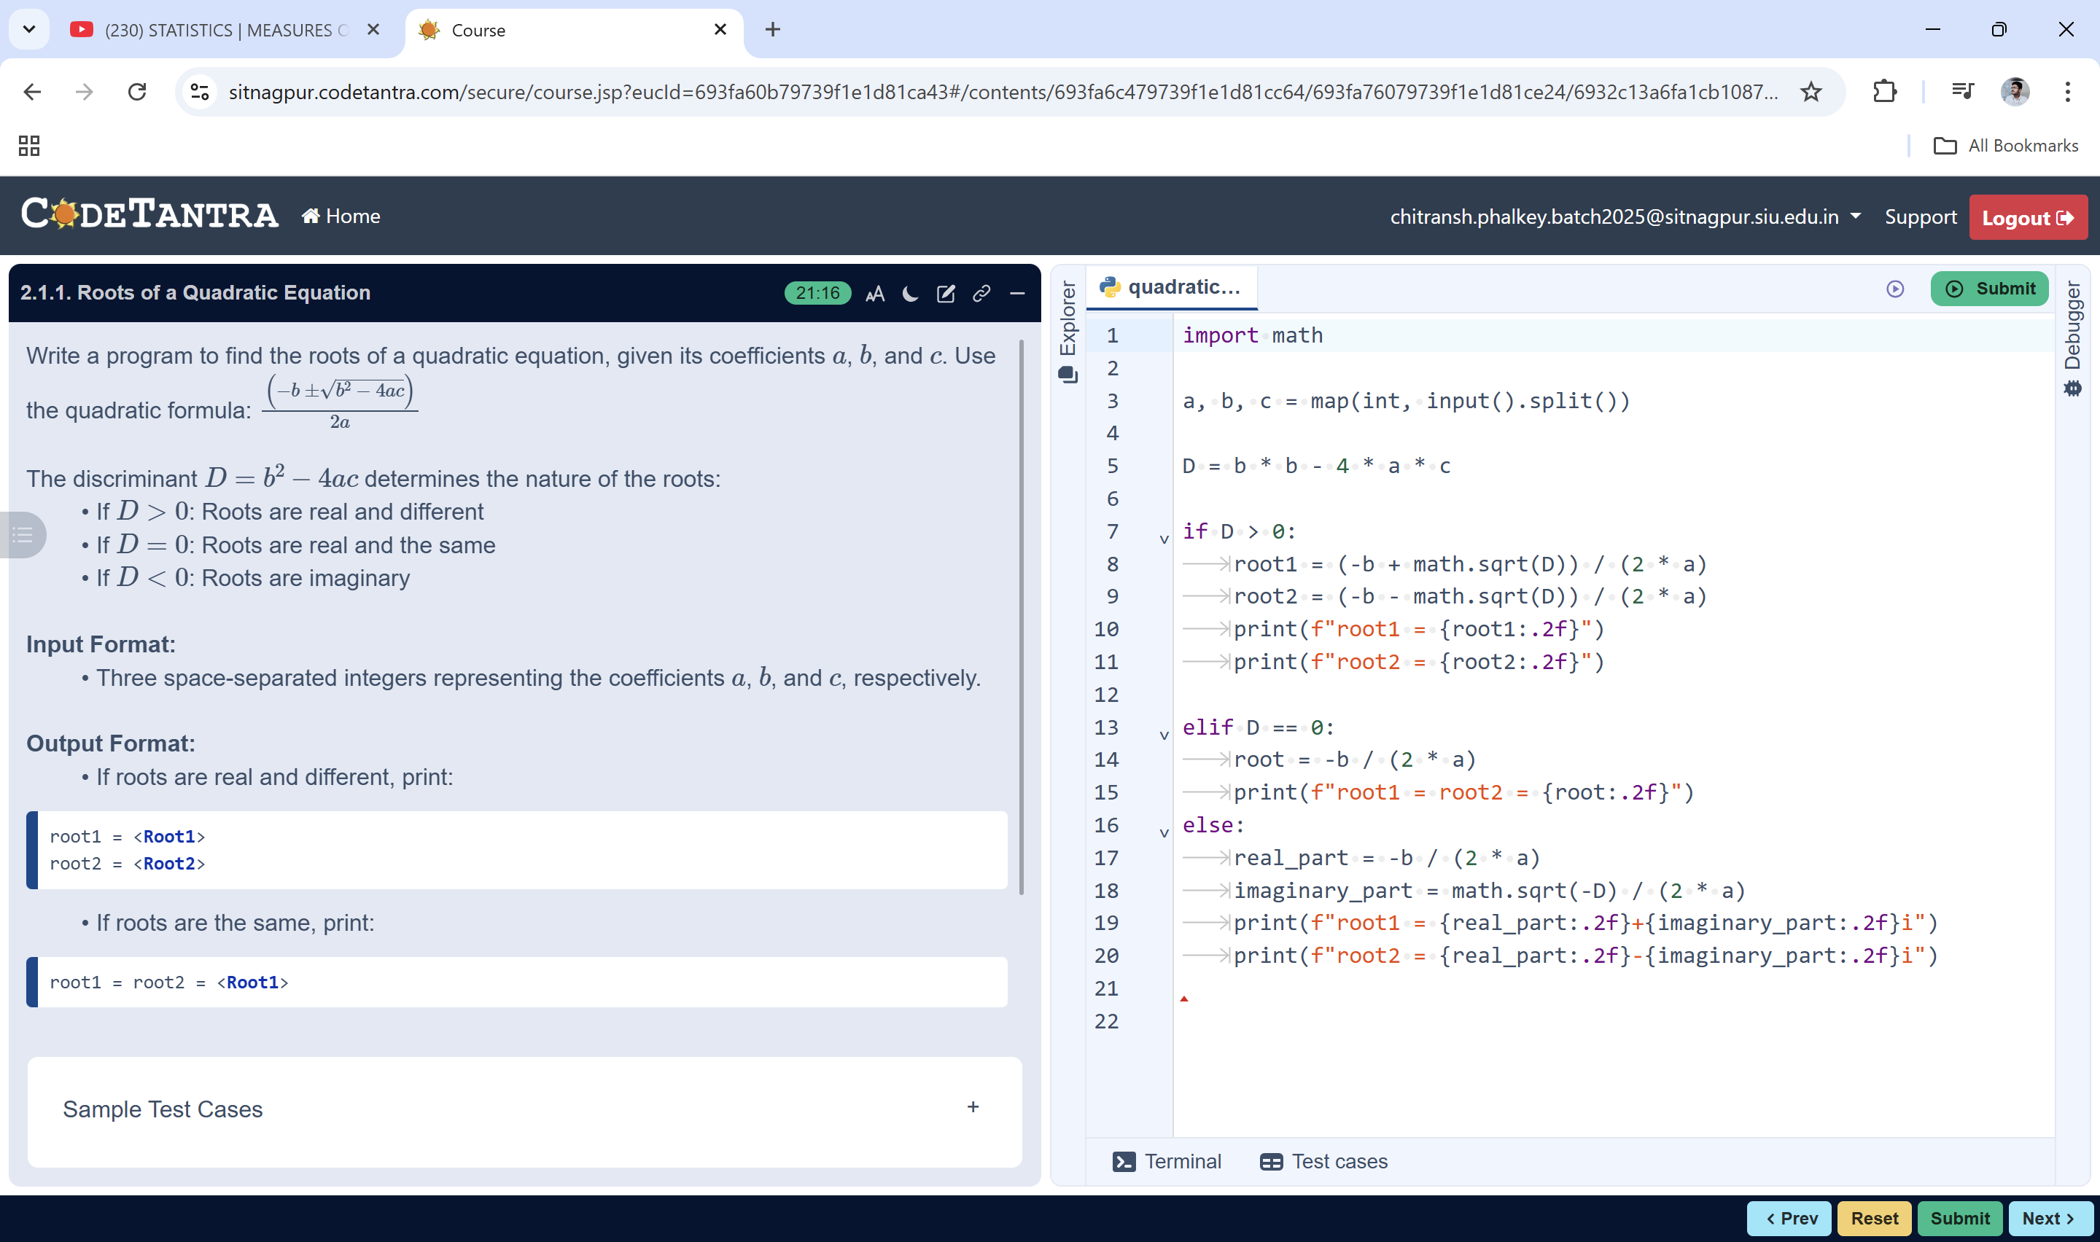
algorithm: To Find the Roots of a Quadratic Equation
Step 1: Start
Step 2: Read the values of a, b and c
Step 3: Calculate the discriminant
D = b * b − 4 * a * c
Step 4: Check the value of D
If D > 0, then
root1 = (−b + √D) / (2 * a)
root2 = (−b − √D) / (2 * a)
Print root1 and root2
Else if D = 0, then
root = −b / (2 * a)
Print root1 = root2 = root
Else
real_part = −b / (2 * a)
imaginary_part = √(−D) / (2 * a)
Print
root1 = real_part + imaginary_part i
root2 = real_part − imaginary_part i
Step 5: Stop

